Solution to every third end-of-chapter problem
Basics of Engineering Economy, 2nd edition
Leland Blank and Anthony Tarquin

Chapter 9
Replacement and Retention Decisions

9.1 The defender refers to the currently-owned, in-place asset while the challenger
refers to the equipment/process that is under consideration as its replacement.

9.4 P = market value = $39,000
AOC = $17,000 per year
n = 4 years
S = $25,000
(Note: P and AOC will carry – signs in an evaluation)

9.7 The ESL of the defender is 3 years with the lowest AW of $-85,000.

9.10 Add AW values for first cost, operating cost, and salvage value; select lowest AW.

Years Retained Total AW
1 $-102,000
2 -84,334
3 -84,190
4 -83,857
5 -84,294
Economic service life is n = 4 years.

9.13 (a) Tabulated factors
AW₁ = -65,000(A/P,10%,1) – 50,000 + 30,000(A/F,10%,1) = $-91,500

AW₂ = -65,000(A/P,10%,2) – [50,000 + 10,000(A/G,10%,2)]
+ 30,000(A/F,10%,2)
= $-77,929

AW₃ = -65,000(A/P,10%,3) – [50,000 + 10,000(A/G,10%,3)]
+ 20,000(A/F,10%,3)
= $-79,461

AW₄ = -65,000(A/P,10%,4) – [50,000 + 10,000(A/G,10%,4)]
+ 20,000(A/F,10%,4)
= $-80,008

AW₅ = -65,000(A/P,10%,5) – [50,000 + 10,000(A/G,10%,5)]
+ 20,000(A/F,10%,5)
= $-81,972

AW₆ = -65,000(A/P,10%,6) – [50,000 + 10,000(A/G,10%,6)]
+ 20,000(A/F,10%,6)
= $-84,568

AW₇ = -65,000(A/P,10%,7) – [50,000 + 10,000(A/G,10%,7)]
+ 20,000(A/F,10%,7)
= $-87,459

ESL is n = 2 years with AW = $-77,929

(b) Spreadsheet solution shows ESL is n = 2 years with AW = $77,929

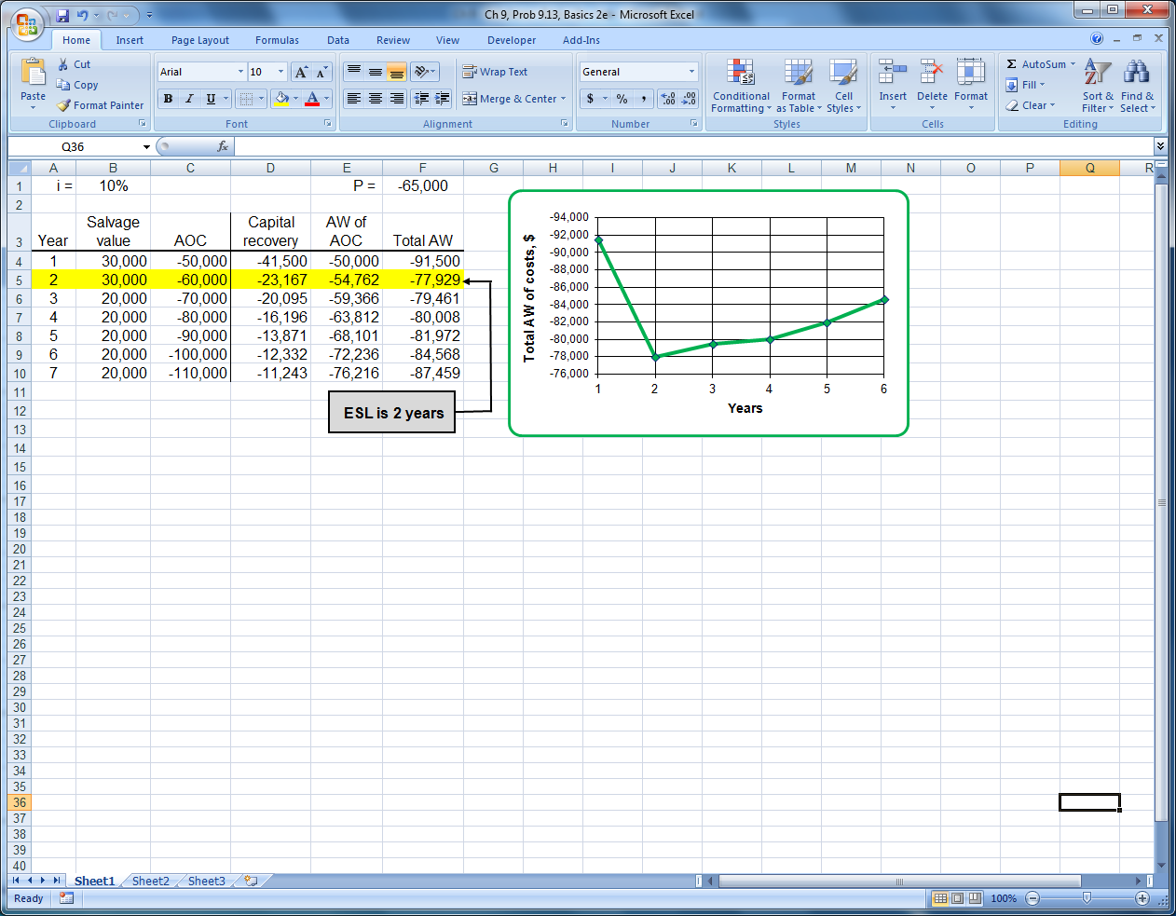

9.16 AW_{C} = -80,000(A/P,12%,3) - 19,000 + 10,000(A/F,12%,3)
= -80,000(0.41635) - 19,000 + 10,000(0.29635)
= $-49,345

AW_{D} = -10,000(A/P,12%,3) -15,000 – 31,000 + 9000(A/F,12%,3)
= -10,000(0.41635) -15,000 – 31,000 + 9000(0.29635)
= $-47,496

AW_{D} = -20,000(A/P,12%,3) -15,000 – 31,000 + 9000(A/F,12%,3)
= -20,000(0.41635) -15,000 – 31,000 + 9000(0.29635)
= $-51,660

Trade-in of $10,000: Select the defender

Trade-in of $20,000: Select the challenger

9.19 No option of retention of defender D more than one year

AW_{D} = -9000(A/P,10%,1) – 192,000
= -9000(1.1000) -192,000
= $-201,900

AW_{C} = -320,000(A/P,10%,4) – 68,000 + 50,000(A/F,10%,4)
= -320,000(0.31547) – 68,000 + 50,000(0.21547)
= $-158,177

Replace the defender now with System C

9.22 -RV(A/P,8%,3) – 60,000 + 15,000(A/F,8%,3) = -80,000(A/P,8%,5)
- [40,000 + 2000(A/G,8%,5)] + 20,000(A/F,8%,5)

-RV(0.38803) – 60,000 + 15,000(0.30803) = -80,000(0.25046)
- [40,000 + 2000(1.8465)] + 20,000(0.17046)

-0.38803 RV = 4941.05
RV = $12,734

9.25 -RV(A/P,12%,4) – [40,000 + 2000(A/G,12%,4)] = -150,000(A/P,12%,10)
- [10,000 + 500(A/G,12%,10)] + 50,000(A/F,12%,10)

-RV(0.32923) – [40,000 + 2000(1.3589)] = -150,000(0.17698)
- [10,000 + 500(3.5847)] + 50,000(0.05698)

-0.32923RV = -35,490 + 42,718

RV = $21,954

9.28 Only 2 options; replace defender, buy challenger now or retain defender for 3 years.

AW_{D} = - (40,000 + 70,000)(A/P,15%,3) – 85,000 + 30,000(A/F,15%,3)
= -110,000(0.43798) – 85,000 + 30,000(0.28798)
= $-124,538

AW_{C} = -220,000(A/P,15%,3) – 65,000 + 50,000(A/F,15%,3)
= -220,000(0.43798) – 65,000 + 50,000(0.28798)
= $-146,957

Keep the defender

9.31 Answer is (a)

9.34 Answer is (b)

9.37
Option | Years for Defender | Years for  Challenger | AW, cash flows, $ per year |  |  | Option AW, $/year
Option | Years for Defender | Years for  Challenger | Year 1 | Year 2 | Year 3 | Option AW, $/year
A | 0 | 3 | -73,000 | -73,000 | -73,000 | -73,000
B | 1 | 2 | -74,000 | -84,000 | -84,000 | -80,192
C | 2 | 1 | -74,000 | -74,000 | -84,000 | -76,880
Option A: AW = $-73,000

Option B: AW = -84,000 + 10,000(P/F,15%,1)(A/P,15%,3)
= -84,000 + 10,000(0.8696)(0.43798)
= $-80,192

Option C: AW = -74,000 - 10,000(A/F,15%,3)
= -74,000 - 10,000(0.28798)
= $-76,880

Select option A: Replace now.

Answer is (a)

